

Salesforce Example

How to remove a security key from your Salesforce account
This guide will walk you through the process of how to remove a security key if you have one registered for MFA on your Salesforce account
  Click on your profile picture    Click on Settings | 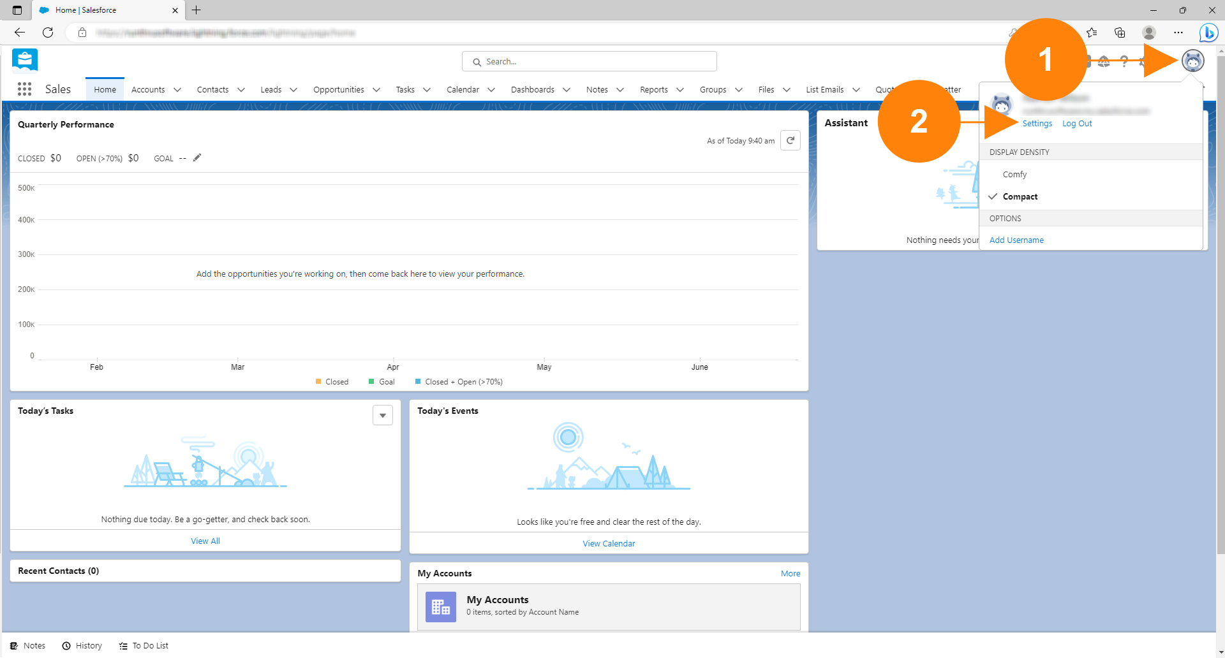
  Click on Advanced User Details in the My Personal Information Section | 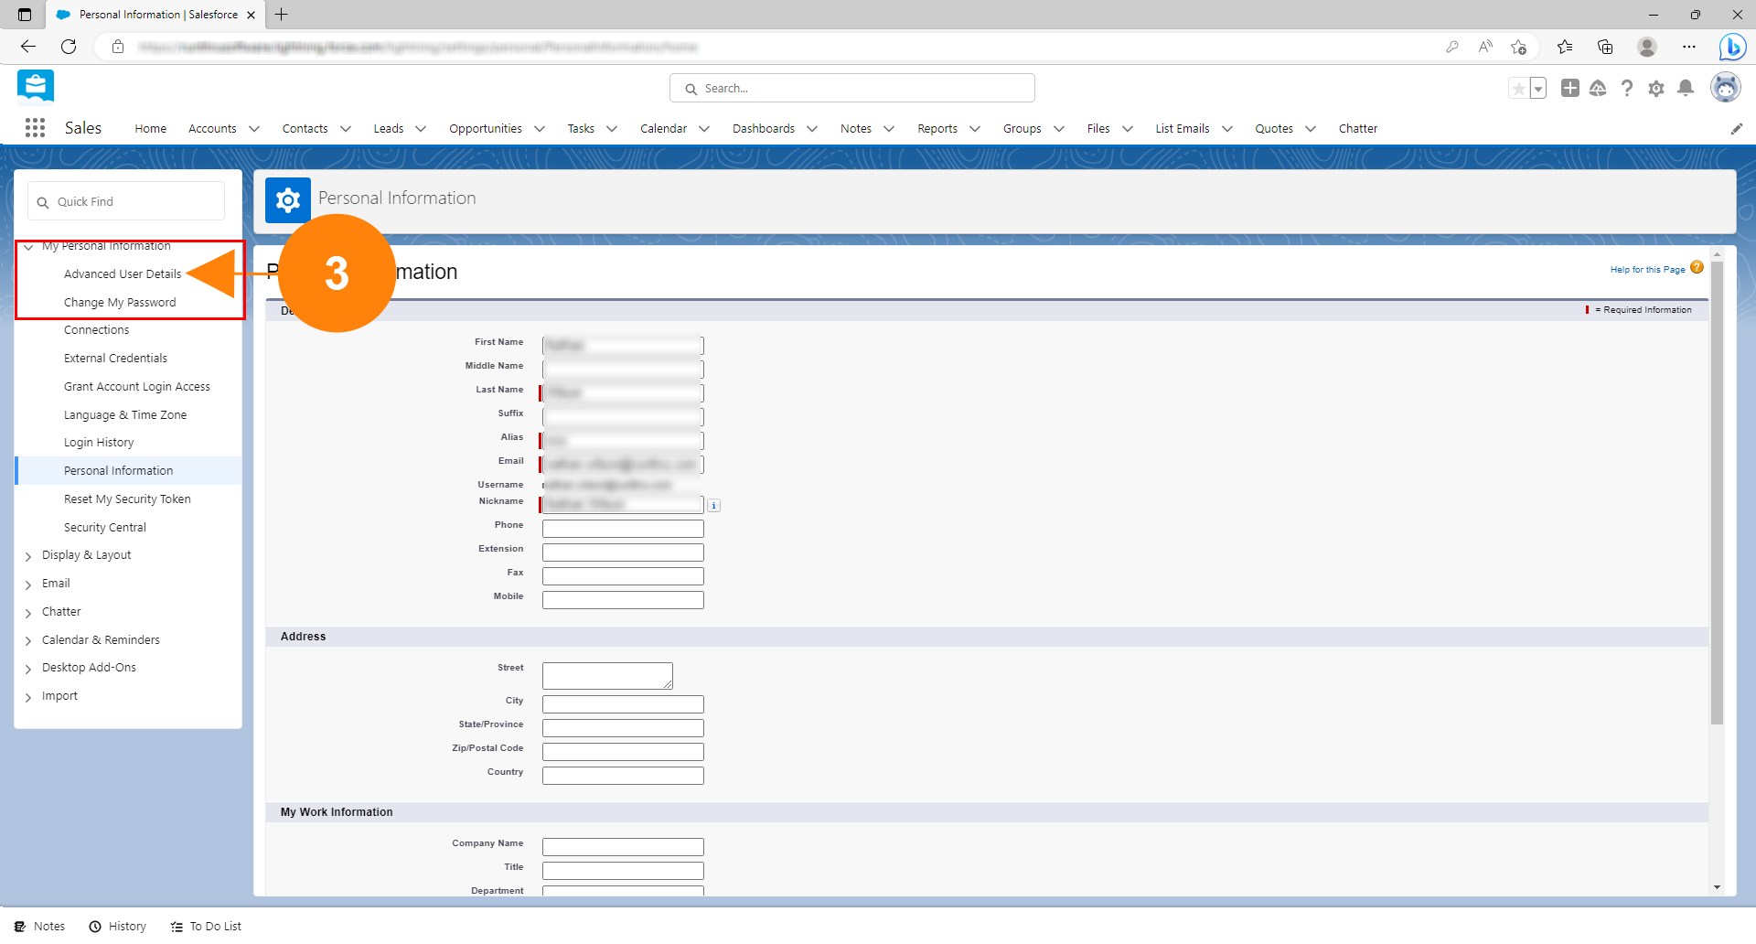
  Click the [Remove] button inline with Security Key as shown. | 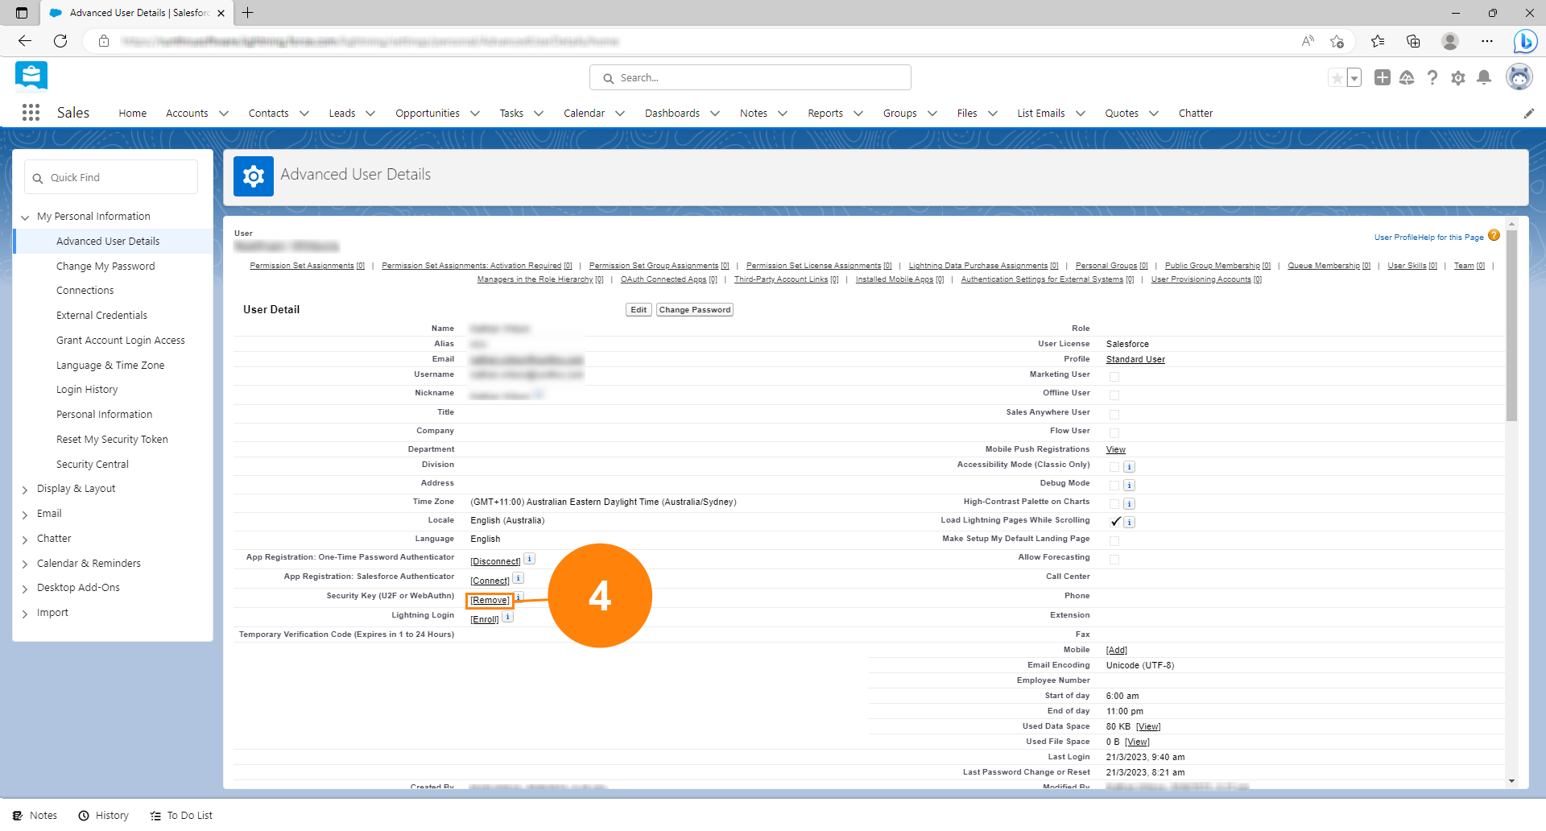
  The button will now say [Register] indicating that you have successfully removed your key | 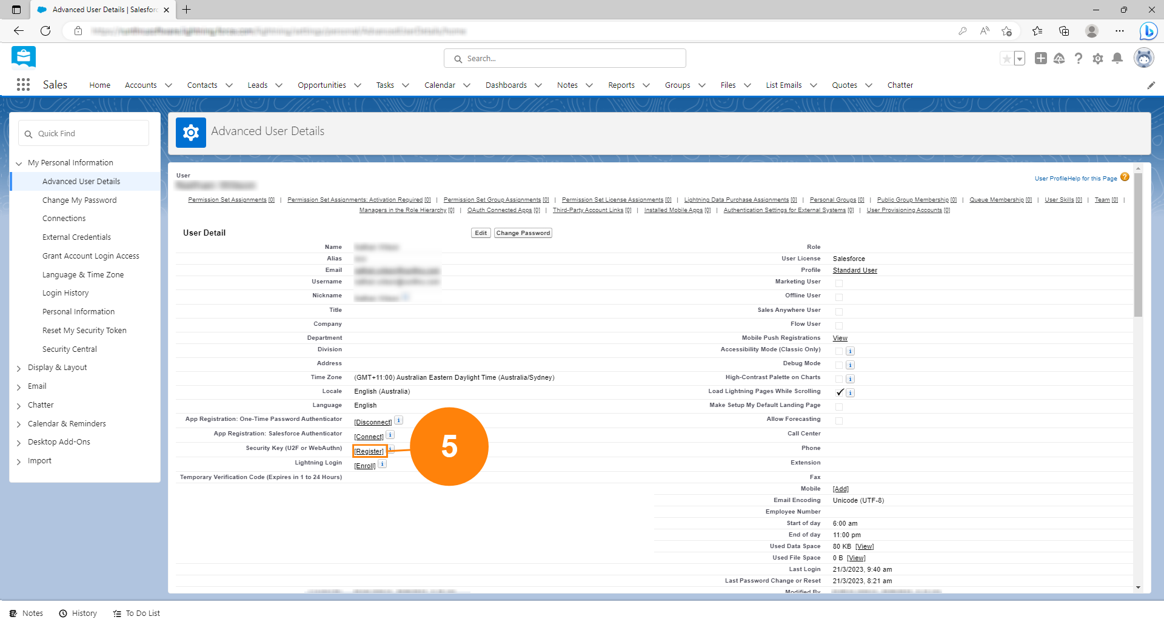

You're done!
Congratulations, you've reached the end of the guide

